Desert Island Drawing
Task
Design your own desert Island
This is a drawing where you can use your imagination. You can make your island any shape you want any size you want and put onto it whatever you want.
Below is a drawing of my desert island. I like mountains, lakes and forests (and baby pandas) so I have put all of those things on my island.
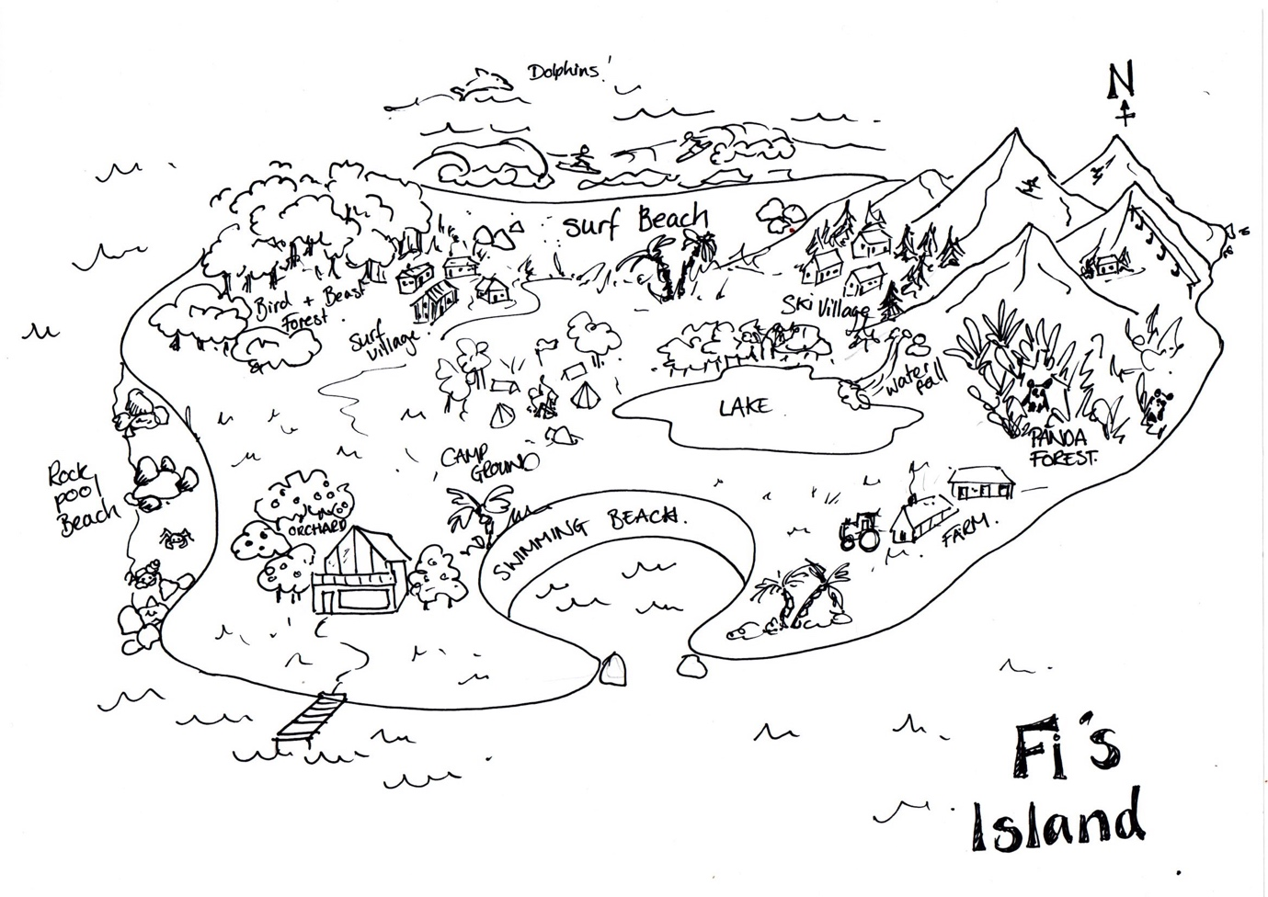
My sons would definitely put different things on theirs. Two of my sons love skateboarding, scooters and parkour so they would have lots of parks to do those things. The other loves fish so he would have aquariums and coral reefs for diving. What do you want on your island?

Artists Islands
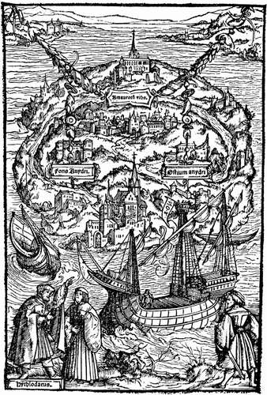
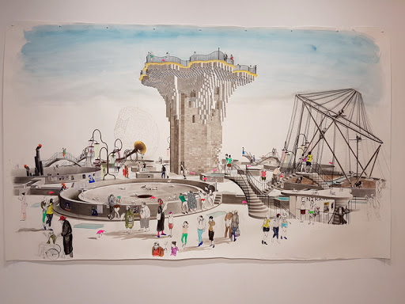
Lots of artists enjoy designing islands too. This is one that was made in 1518 by an artist called Ambrosius Holbein to illustrate a book by Thomas More called Utopia. ‘Utopia’ is a word that means a perfect place to live.

There is an artist called Charles Avery who has made up an imaginary island. All his work, paintings, drawings, writing and sculpture is used to describe the people, animals and places on this island. Even the stars and moon. There is a main town called Onomatopoeia and an Eternal Forest where an animal called a Noumenon lives.

These are two of my families favourite imaginary Islands from books we have read. Wild Cat Island from Swallows and Amazons and The Island of Berk from How to Train your Dragon drawn by the amazing illustrator Neal Layton.

